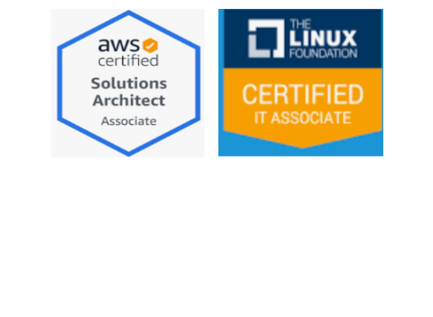

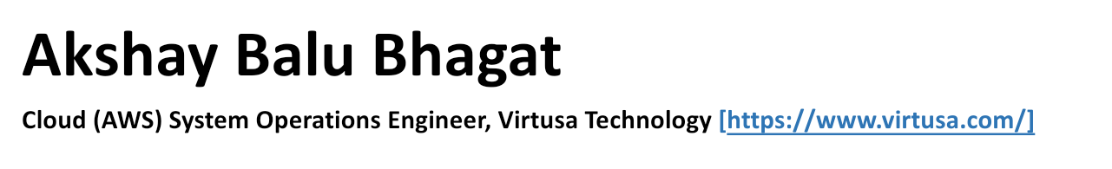

**EXPERIENCE SUMMARY**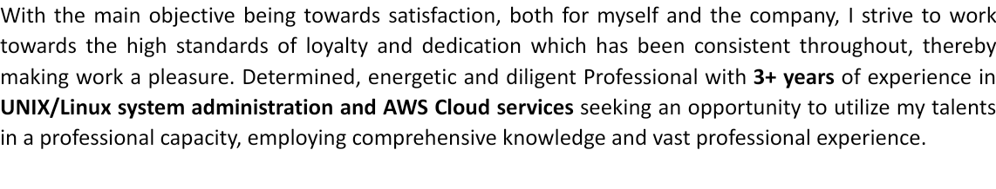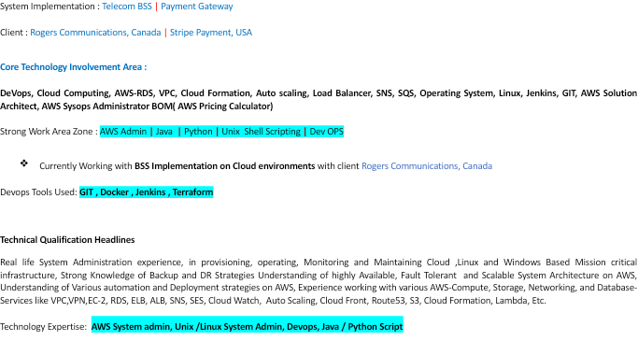

* Manage Amazon Web Service - ELB, EC2, S3, RDS, SNS, Cloud Watch,Creating/Managing AMI/Snapshots/Volumes, Upgrade/downgrade AWS resources (CPU, Memory, EBS)
* Experience in architecting secure VPC solutions on AWS with the help of network ACLs,security groups, public and private network configuration
* Setup/Managing Linux Servers on Amazon ( EC2, EBS, ELB, SSL, Security Groups, RDS and IAM).
* Setup/Managing VPC, Subnets; make the connection between different zones; Blocking suspicious ip/subnet via ACL.
* Create S3 buckets and also managing policies for S3 buckets
* Experience in managing and maintaining IAM policies for organisations in AWS to define groups, create users, assign roles and define rules for role based access to AWS resources
* Create snapshots and amazon machine images (AWS) of the instances for backup and creating clone instances
* Used JIRA to track issues and change management, Creating/Managing AMI/Snapshots/Volumes, Upgrade/downgrade AWS resources (CPU, Memory, EBS)
* Troubleshoot Nagios Alerts
* Manage systems routine backup, scheduling jobs, enabling cron jobs, enabling system logging and network logging of servers of maintenance
* Create and maintain user's accounts, profiles, security, rights disk space and process monitoring
* Provide technical support by troubleshooting day-to-day issues with various servers on different platforms
* Installed Red Hat Enterprise Linux using Kickstar and applying security policies for hardening the server based on the company policies
* Created and maintained user accounts, profiles, security, rights, disk space and process monitoring
* Excellent knowledge of service like DNS, DHCP, NFS, Send mail, Apache Web Server, Samba, SSH, Telnet, HTTP, YUM, RPM package management
* Developed UNIX shell scripts to accomplish redundant tasks to simplify in distributed administration
* Built up Linux servers using PXE kic-start services
* Performed daily system monitoring, verified the integrity and availability of all hardware and server resource and reviewed system and application logs
* Evolited performance of system to see that they meet business needs

**TECHNICAL SKILLS**

* + Operating Systems Windows 95/98/2000/NT/XP, UNIX, Linux
  + Languages C, C++, Python, SQL, PL/SQL,
  + O.S: Red Hat, Cent OS, Solaris
  + Scripting: Bash, Python(Basic)
  + Web: Apache, Apache Tomcat,Nginx
  + Automation: Ansible
  + Backup: NetBackup, rsync, tar, zip
  + Networking: DNS, TCP/IP, DHCP, SSH, SAMBA, LDAP
  + Security: firewalld, iptables, selinux
  + Monitoring: Nagios, AWS Cloudwatch
  + Troubleshooting: top,free, ping, tcpdump, telnet, netstat, traceroute
  + Virtualization: VWWare ESXi, KVM, Vsphere web client
  + AWS: S3, IAM, Route53, VPC, SNS, ELB, cloudwatch, Auto Scaling
  + Atlassian tools: JIRA

**WORKING ZONE- ORGANISATION**

Currently working as a **Cloud (AWS) System Operations Engineer** with Virtusa Technology [https://www.virtusa.com/], Pune since November 2021 to till date.

**PROJECT DETAILS**

**Project Sequence 1**

Project Name : **5G Commercialization**

Client: Rogers Communications, Canada

System: - Telecom BSS ,CRM ,Mediation System

Roles : AWS –Cloud system Administrator

**Project Detail Description :**

5G revenues are projected to increase as customers migrate from 4G and CSPs design new use cases. CSPs need a clear and pragmatic approach to transforming their organizations,

5G is the next generation mobile technology It will enable a host of rich multimedia services such as video calling, video on demand, and provide a richer experience for existing services such as mobile internet, mobile TV and MMS.5G networks operate on technology called High Speed Downlink Packet Access (HSPA). Data is transmitted many times faster than earlier 2G/3G networks. This basically means that in addition to the earlier audio, graphics, and text, you can now send and receive video content too. Monitoring and measuring critical VoIP call quality components is relatively easy if you have the right CDR analysis using DWH. Mediation is the process of collecting and processing usage data from networked devices, usually for billing purposes. Quality VoIP calls require an IP network that can deliver voice packets within the minimum requirements around jitter, packet loss, and latency. This solution allows user to report on CDRs to identify low performance VoIP metrics, find other calls affected, and identify potential patterns on Cisco VoIP networks. In-depth VoIP call metrics in this solution allows user to view call path details, call signalling, and find the root cause of the issue.

At Mediation there are following tasks performed.

Collecting and validating CDR from network elements (Switches / MSC’s), Filtration (non billing CDR’S)

Correlation of different input sources CDR’s, Aggregation of partial CDRs related to the same call,

CDR normalization., Transformation of data as per business logic, Downstream Format mapping, header and trailer generation, Downstream Distribution. Whenever a Subscriber / Customer uses communication services (Voice, Call, MS, Data transfer etc.) from a Service Provider, Usage Data are generated at the network element. The usage data is called as Call Detail Record (CDR) in the traditional voice network environment or Internet Protocol Detail Record (IPDR) in the data network environment. Some of the Service Usage Data sources in the network are:

GSM telephony Network Elements GSM telephony, Voice calls – MSC, SMS traffic – SMSC, Data traffic – GGSN, MMS traffic – MMSC Roaming CDRs from business partners, Interconnect CDRs from partners

The CDRs are normally pushed to or pulled from the switches. The switch generates a CDR file. These file contains header or trailer records containing the number of CDRs in a particular file. The files are generated as they reach a specified count or at regular time intervals.

**Operation and responsibilities**

▪ Establish metrics and carefully monitor the utilization of AWS resources on a wide scale by making use of highly sophisticated Amazon Cloud Watch.

▪ Wrote python scripts to Monitor a variety of admin services

▪ Maintaining a backup of the resources and performing AWS on premise resources backup from time to time by making extensive use of AWS services.

▪ Optimize the resources & work on resource tagging to allocate costs and for carefully planning of budgeting, governance, and reporting.

▪ Involved in Commercial Cloud Services (C2S) and Creates effective presentations that support C2S overviews

▪ Creating and managing VPC, URL proxies, C2S access points & as well as Bastion Hosts.

▪ To communicate with the NISP network team in order to finalize the network connections for the clients VPCs.

▪ Effectively monitor billing and develop cost optimization strategies.

▪ monitor the availability and to measure the extent of performance.

▪ Manage disaster recovery processes, Approve Images For Use As Catalog Items

▪ Set Up An AWS Catalog Offering, AWS Virtual Private Clouds (VPCs)

▪ Amazon Elastic Block Store (EBS) ,Cloud Formation To maintain data integrity and to access the control while using the AWS application platform

**Project Sequence 2**

Title : Control Access to BSS – [ CAtB ]

Client : Rogers Communications, Canada

Migration Tool : AWS Migration Hub

Roles : AWS –Cloud system Administrator

**Project Detail Description:**

This enterprise billing solution delivers the core capabilities user need to automate user quote-to-cash processes

* Creating and managing projects
* Access control for projects with IAM
* Protecting projects from accidental deletion with liens
* Troubleshooting project deletion

The leading Integrated cloud billing platform that accurately predicts and optimizes virtual resource usage and spend across public clouds. Integrated Cloud Billing enables organisations to monitor and manage cloud hosted services across a range of providers.

This solution offers a global platform, which is built on open source technology and has multi-tenant configuration to support multiple products and service packages. This Cloud Solution Can be installed in both private (your own servers in user hosting facility) and public clouds. Rogers Communications, Canada Billing in a public cloud is available as an all-inclusive service where users do not need to purchase any licenses, procure the hardware and arrange the hosting. Instead, users may simply decide on the starting cloud billing capacity and it instantly provides the user with a ready-to-use billing platform operating in a cloud. With Rogers Communications, Canada Billing in a cloud, business will be faster and speed up payback.

The key peculiarities of the cloud-based Solutions are:

Deployment in Oracle cloud where the cloud infrastructure is maintained by Aussie Broadband provides enormous savings on hardware purchase, hosting, provisioning, and maintenance;

Reduced deployment time as you get the access to your billing in a cloud within a day;

Ultimately flexible scalability as user make his own decision on the required processing capacity that can be increased on demand at any time;

Usage based service subscription fees that are based on maximal number of concurrent calls and the amount of billable events processed by the cloud billing on a monthly basis.

**Operation and Responsibilities**

▪ Establish metrics and carefully monitor the utilization of AWS resources on a wide scale by making use of highly sophisticated Amazon Cloud Watch.

▪ Maintaining a backup of the resources and performing AWS on premise resources backup from time to time by making extensive use of AWS services.

▪ Optimize the resources & work on resource tagging to allocate costs and for carefully planning of budgeting, governance, and reporting.

▪ Involved in Commercial Cloud Services (C2S) and Creates effective presentations that support C2S overviews

▪ Creating and managing VPC, URL proxies, C2S access points & as well as Bastion Hosts.

▪ To communicate with the NISP network team in order to finalize the network connections for the clients VPCs.

▪ Effectively monitor billing and develop cost optimization strategies.

▪ monitor the availability and to measure the extent of performance.

▪ Manage disaster recovery processes.

▪ Approve Images For Use As Catalog Items, Set Up An AWS Catalog Offering, AWS Virtual Private Clouds (VPCs), Amazon Elastic Block Store (EBS), Cloud Formation

**PROJECT SEQUENCE 3:**

Project Name : Unified Payment Terminal

Client: Stripe ,USA

System: Payment

Roles: Unix /Linux system Administrator

**Project Detail Description :**

This project team is responsible for Providing administration for business critical markets Business on a daily basis. The admin team provides technical expertise and system architecture recommendations suitable for all unix/linux projects. The team provides advanced subject matter expertise to the market business and support groups that include troubleshooting, performance analysis

and sizing recommendations and problem resolutions. partner with global unix support SMES

and application architect and key decision maker across the Application team.

**Operation and Responsibilities** :

▪ Installing, Tuning, Troubleshooting and patching of redhat enterprise Linux servers

▪ Installation and configuration of weblogic and WebSphere application server.

▪ Installation, Maintenance and configuration of Web Servers, Application servers, Database servers on linux servers

▪ Scheduled various regular, periodic, future and queue tasks by using crontab

▪ Monitoring server performance and troubleshooting servers related problems to SNMP

▪ Process administration and management like monitoring, start/stop kill various processes /Sub process

▪ Monitor system performance parameters using Iostat, vmstat and fine tuning

▪ Creating and maintaining user accounts, Profiles and security rights

▪ Installation upgrade, system startup , and shot down as needed

▪ Wrote simple bash scripts to ping servers and user to the boxes

▪ Resolved system errors and crashes, disk space problems, huge file sizes and file system full errors

▪ Dealt with ESX, ESXi servers ,Working experience on windows active directories and LDAP

▪ Supported 200 + AWS Cloud Instances running Ubuntu, redhat and windows environments

▪ Wrote python scripts to Monitor a variety of admin services

▪ Build Channels and pull Packages from master red hat satellite servers

▪ Ensure Data centres operation meets required service levels, Worked on KVM and VM wire

**PERSONAL DETAILS**

* Fathers Name: Balu Bhaurao Bhagat
* Mother's Name: Urmila
* Permanent Address: 503, Durvankar Heights, Jai Bhavani Road, Nashik Road, Nashik-422101
* Date of Birth: 10/03/1997
* Marital Status: Unmarried
* Gender: Male
* Languages: English, Hindi, Marathi

**Declaration: -**

I hereby declare that the above-mentioned information is correct to the best of my knowledge.

Date:

Location:

Regards,

Akshay Balu Bhagat